## **Assignments**

Bookmark this page

**Brief for Assignment 1, 2, & 3:**

We need to understand the distribution of duration of trending videos. The videos can trend on multiple days. The popular videos such as new songs, trailer trend longer compared to one of the viral videos. Hence it is important to understand the distribution of duration of videos trending by their respective category. We will need to run a few sql queries to analyze the distribution.

### Assignment 1

1/1 point (graded)

Create a report for overall distribution of duration of trending videos by each country. The report will have video_id, video name (title), country, No_of_days_trended. Sample report:

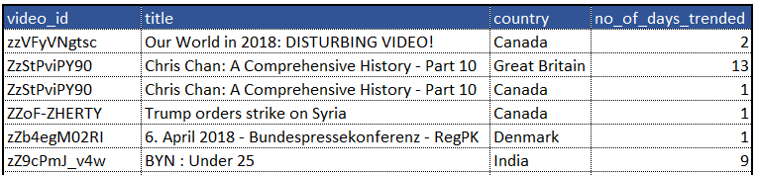

**Task:** Save the report with assignment number in the Google work sheet as mentioned previously.

**Question**: How many videos have trended for more than 5 days in the US?

**SELECT** country,

Count(video_id) AS no_of_videos

**FROM**  (SELECT video_id,

title,

country,

Count(trending_date) AS no_of_days_trended

**FROM** yt_trending_videos

**GROUP BY** video_id,

title,

country) a

**WHERE** no_of_days_trended > 5

AND country = 'US'

**GROUP BY** country

### Assignment 2

1/1 point (graded)

Create a report for overall distribution of duration of trending videos by each category. The report will have video_id, category title, No_of_days_trended.

Sample report:

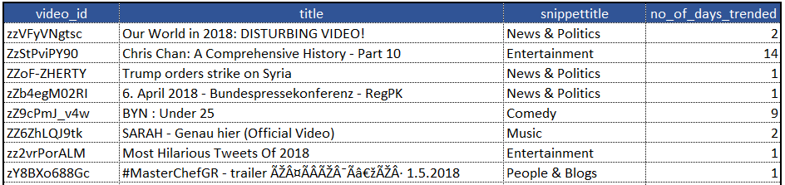

**Task:** Save the report with assignment number in the Google work sheet as mentioned previously.

**Question:** Which category has the highest average trending period?

**SELECT** snippettitle AS category_title,

Avg(no_of_days_trended) AS avg_trending_days

**FROM**  (SELECT video_id,

title,

snippettitle,

Count(trending_date) AS no_of_days_trended

**FROM**  yt_trending_videos a

INNER JOIN yt_category_map b

ON a.category_id = b.id

**GROUP BY** video_id,

title,

snippettitle) a

**GROUP BY** snippettitle

**ORDER BY** avg_trending_days DESC

### Assignment 3

1/1 point (graded)

Create a report for the number of distinct videos trending from each category on day of the week. The report will have weekday, category title, No_videos_trended. Sample report:

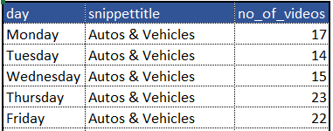

**Note:** The answer cannot be derived from the report. In the report, we have a number of videos trending for each weekday by category. Hence, if a video has trended on multiple days, it will be counted on each day. The question asks for distinct videos and hence write the query considering that.

**Task:** Save the report with assignment number in the Google work sheet as mentioned previously.

**Question**: How many distinct videos trended from the category ‘Music’ on weekdays (Monday - Friday)?

**SELECT** snippettitle,

Count(DISTINCT video_id) AS no_of_videos

**FROM**  yt_trending_videos a

**INNER JOIN** yt_category_map b

ON a.category_id = b.id

**WHERE** Weekday(trending_date) BETWEEN 0 AND 4

AND snippettitle = 'Music'

**GROUP BY** snippettitle

**Brief for Assignment 4 & 5:**

Normally it is believed if the video trends for more number of days, then the video views, likes and comments also is higher. We need to check whether this is true for all the videos.

### Assignment 4

1/1 point (graded)

Create a summary report which contains country, category title, total_views, total_likes and avg_trending_days. Sample report:

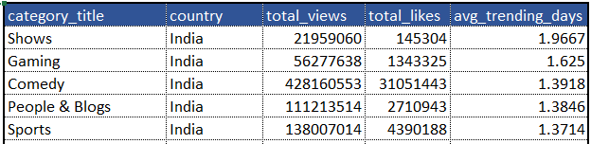

**Task:** Save the report with assignment number in the Google work sheet as mentioned previously.

**Question**: What are the total views for category sports in ‘Canada’?

**SELECT** snippettitle AS category_title,

country,

Sum(total_views) AS total_views,

Sum(total_likes) AS total_likes,

Avg(no_of_days_trended) AS avg_trending_days

**FROM**  (SELECT video_id,

title,

snippettitle,

country,

Sum(views) AS total_views,

Sum(likes) AS total_likes,

Count(trending_date) AS no_of_days_trended

FROM yt_trending_videos a

INNER JOIN yt_category_map b

ON a.category_id = b.id

GROUP BY video_id,

title,

snippettitle,

country ) c

**WHERE** country = 'Canada'

AND snippettitle = 'Sports'

**GROUP BY** snippettitle,

country

**ORDER BY** country,

avg_trending_days DESC

### Assignment 5

1/1 point (graded)

Rank the videos based on views, likes within each country. Which country has the highest number of videos with rank for views and rank of likes both in top 20?

**SELECT** country,

Count(video_id) AS no_of_videos

**FROM**  (SELECT video_id,

title,

country,

views,

likes,

Rank()

OVER (

partition BY country

ORDER BY views DESC) AS rank_views,

Rank()

OVER (

partition BY country

ORDER BY likes DESC) AS rank_likes

**FROM**  yt_trending_videos) a

**WHERE** rank_views <= 20

AND rank_likes <= 20

**GROUP BY** country

**ORDER BY** no_of_videos DESC

**Brief for Assignment 6 & 7:**

We have determined that the Likes to dislikes ratio is a good indicator of popularity. We have to come up with a rating framework to the videos based on the available metrics, which would help us recommend videos better.

### Assignment 6

1/1 point (graded)

Generate a report at video level with video viewership rating within the category. (Report at video level means the output should be unique at video_id).

**Formula to assign the rating: ((Views - min(views))*100 ) / max(views) - min(views)**

where **max(views)** is maximum views in the respective video’s category

and **min(views)** is minimum views in the respective video’s category

Sample report:

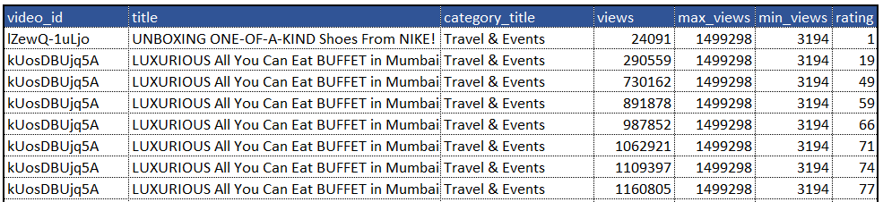

**Task:** Save the report with assignment number in the Google work sheet as mentioned previously.

**Question:** What is the average rating of the category Music?

**SELECT** category_title,

Avg(rating) AS avg_rating

**FROM**  (SELECT c.*,

Round(( ( views - min_views ) * 100 ) / ( max_views - min_views )

, 0) AS

rating

**FROM** (SELECT DISTINCT video_id,

title,

snippettitle AS category_title,

views,

Max(views)

OVER (

partition BY category_id) AS max_views,

Min(views)

OVER (

partition BY category_id) AS min_views

**FROM**  yt_trending_videos a

**INNER JOIN** yt_category_map b

ON a.category_id = b.id) c) d

**GROUP BY** category_title

Assignment 7

1/1 point (graded)

Generate a report at video level with video ratings. (Report at video level means the output should be unique at video_id).

**Rating formula to assign the rating: ((Likes - min(likes))*100 ) / max(likes) - min(likes)**

where **max(likes)** is maximum likes in the respective video’s category

and **min(likes)** is minimum likes in the respective video’s category

Sample report:

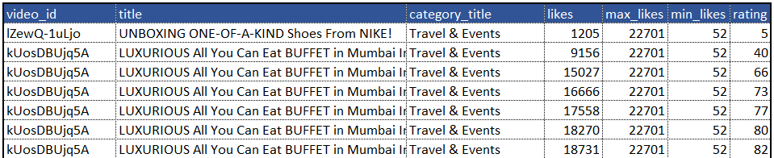

**Task:** Save the report with assignment number in the Google work sheet as mentioned previously.

**Question:** Which category has the highest average rating based on likes?

**SELECT** category_title,

Avg(rating) AS avg_rating

**FROM**  (SELECT c.*,

Round(( ( likes - min_likes ) * 100 ) / ( max_likes - min_likes )

, 0) AS

rating

**FROM**  (SELECT DISTINCT video_id,

title,

snippettitle AS category_title,

likes,

Max(likes)

OVER (

partition BY category_id) AS max_likes,

Min(likes)

OVER (

partition BY category_id) AS min_likes

**FROM**  yt_trending_videos a

INNER JOIN yt_category_map b

ON a.category_id = b.id) c) d

**GROUP BY** category_title

**ORDER BY** avg_rating DESC